INDEX
S. No. | Program Name | Page No. | Date | Signature
8. | Program to demonstrate the concept of destructor. | 13 | 30/03/22
9. | Create the class TIME to store time in hours and minutes. Write a friend function to add two TIME objects. | 14 | 06/04/22
10. | Create two classes DM and DB. DM stores the distance in meters and centimeters and DB stores the distance in feet and inches. Write a program to add object of DM with the object of DB class. | 15 | 13/04/22
11. | Program to overload unary operator. | 17 | 20/04/22
12. | Program to overload binary operator. | 18 | 27/04/22
13. | Program to show multiple inheritance. | 19 | 04/05/22
14. | Program to show Multi-Level Inheritance. | 20 | 04/05/22
15. | Program to show hybrid inheritance. | 21 | 11/05/22
16. | Program to show run time polymorphism using virtual function. | 22 | 18/05/22

Lab-8
Program to demonstrate the concept of destructor.
Code
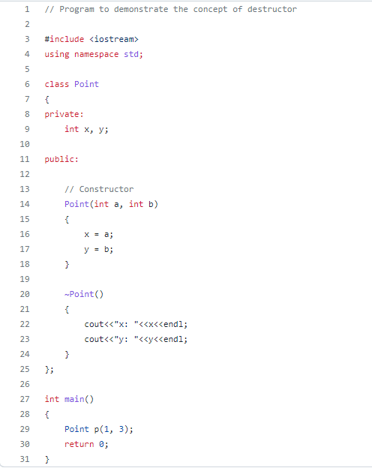
Output
https://github.com/RPChinhara/OOP_Assignments/tree/master/11.%20Destructor
Lab-9
Create the class TIME to store time in hours and minutes. Write a friend function to add two TIME objects.
Code
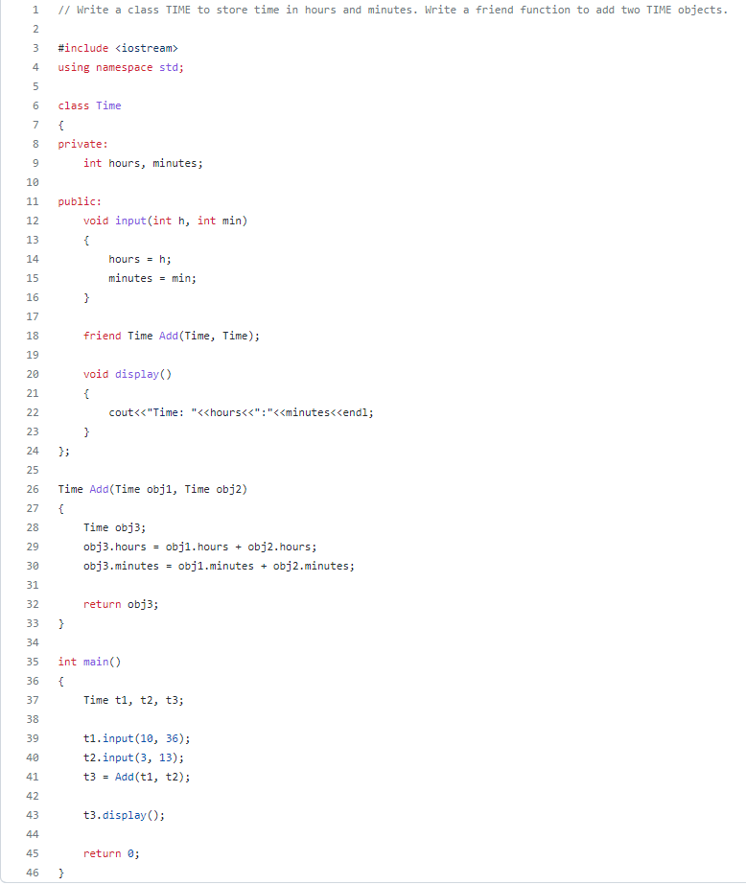

Output
https://github.com/RPChinhara/OOP_Assignments/tree/master/7.%20Time

Lab-10
Create two classes DM and DB. DM stores the distance in meters and centimeters and DB stores the distance in feet and inches. Write a program to add object of DM with the object of DB class.
Code
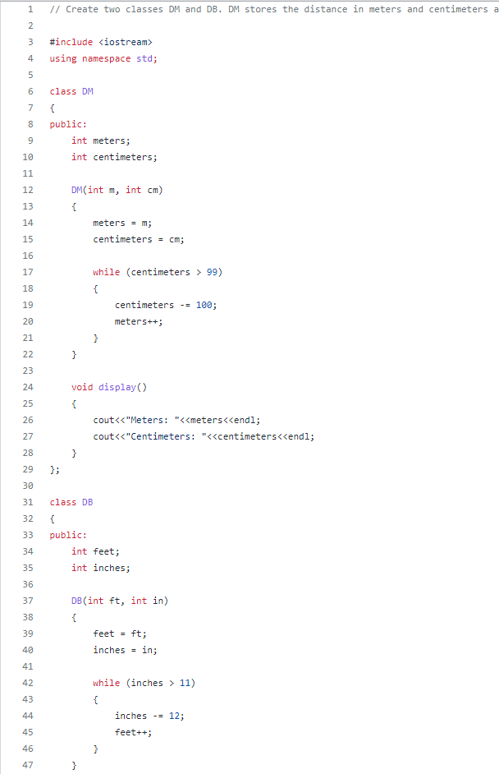

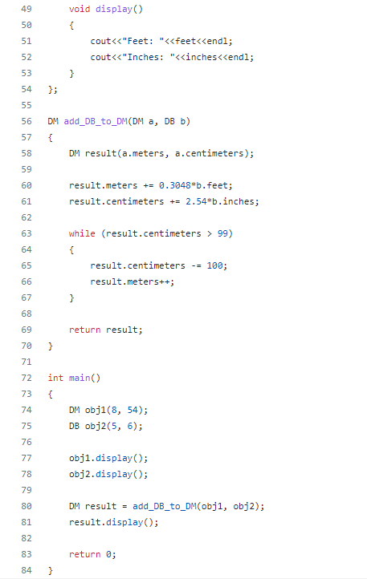
Output
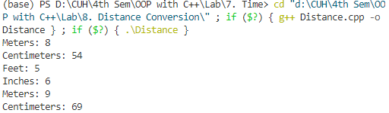
https://github.com/RPChinhara/OOP_Assignments/tree/master/8.%20Distance%20Conversion
Lab-11
Program to overload unary operator.
Code
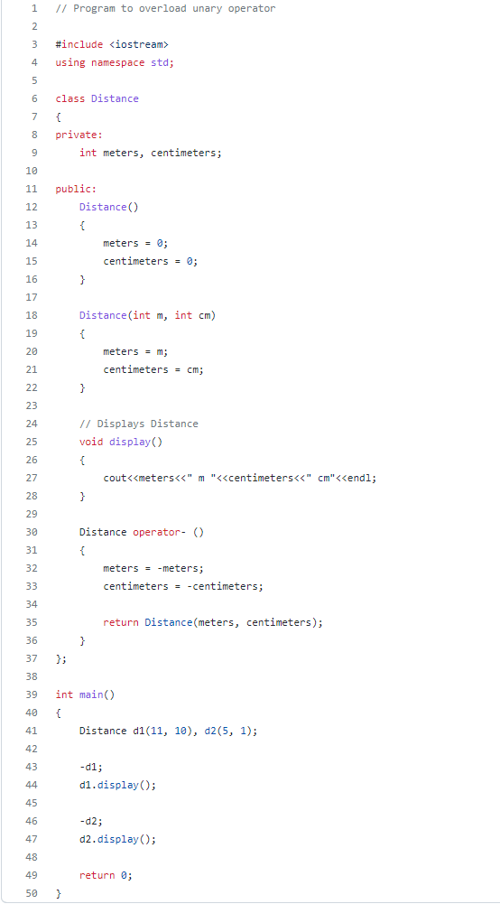
Output
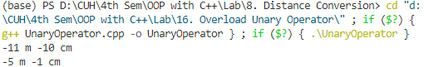
https://github.com/RPChinhara/OOP_Assignments/tree/master/16.%20Overload%20Unary%20Operator
Lab-12
Program to overload binary operator.
Code
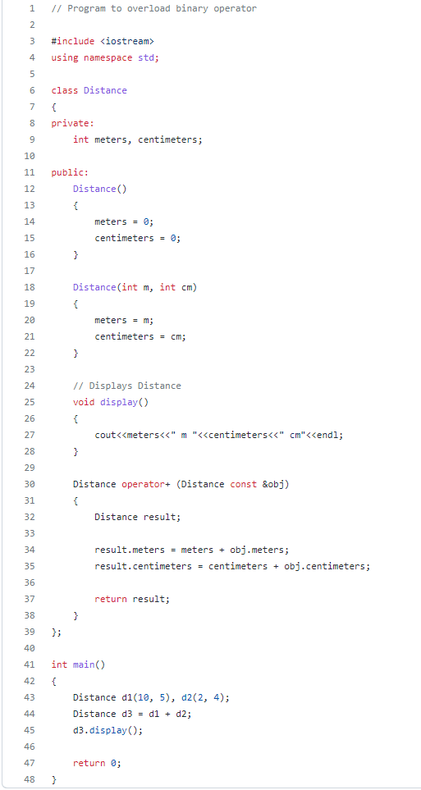
Output
https://github.com/RPChinhara/OOP_Assignments/tree/master/17.%20Overload%20Binary%20Operator
Lab-13
Program to show multiple inheritance.
Code
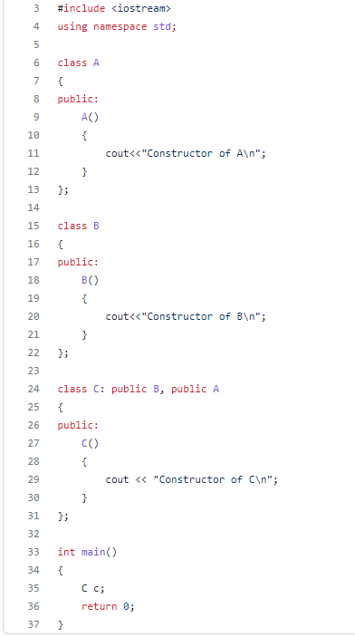
Output
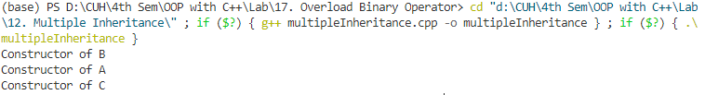
https://github.com/RPChinhara/OOP_Assignments/tree/master/12.%20Multiple%20Inheritance
Lab-14
Program to show Multi-Level Inheritance.
Code
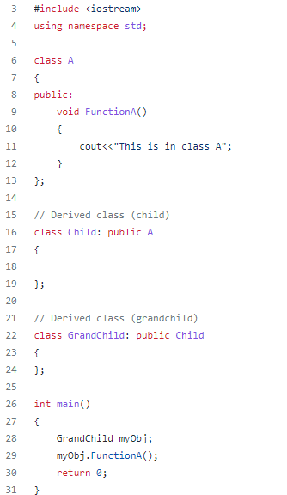
Output
https://github.com/RPChinhara/OOP_Assignments/tree/master/13.%20Multi-level%20Inheritance

Lab-15
Program to show hybrid inheritance.
Code
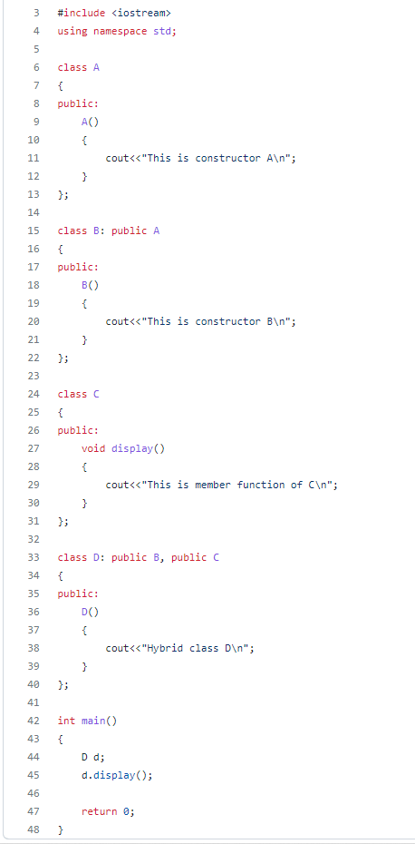
Output
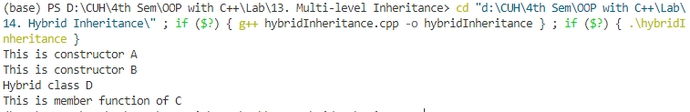
https://github.com/RPChinhara/OOP_Assignments/tree/master/14.%20Hybrid%20Inheritance
Lab-16
Program to show run time polymorphism using virtual function.
Code
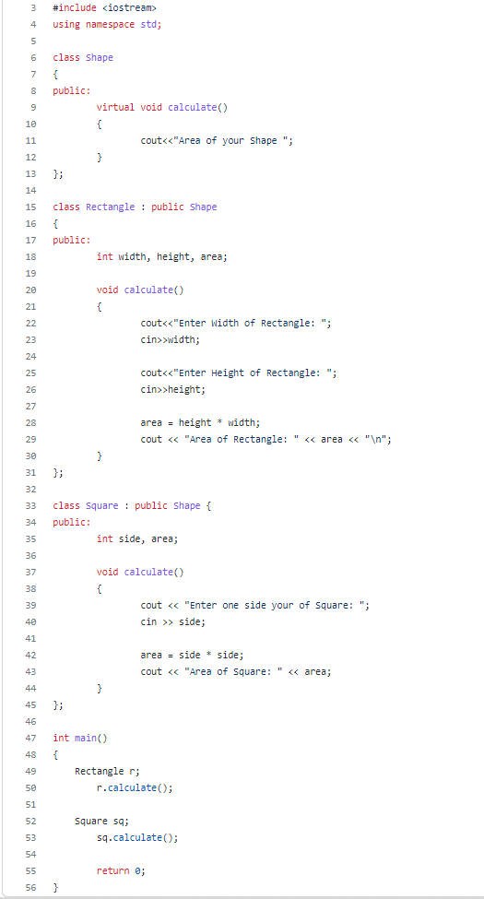
Output
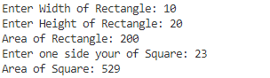
https://github.com/RPChinhara/OOP_Assignments/tree/master/18.%20Polymorphism

